RTLS
RULES: Practical Shooting Handbook, Latest Edition COURSE DESIGNER: Kirt McKenna
START POSITION: Standing anywhere inside the shooting area, facing downrange.
Handgun is unloaded and holstered with wrists above shoulder.
PCC START: Same as handgun with stock on belt and muzzle pointed downrange.
STAGE PROCEDURE  On start signal engage targets as they become visible, from within the shooting area. | SCORING  SCORING: Comstock, 31 rounds, 155 points  TARGETS: 14 IPSC, 3 Mini-Poppers  SCORED HITS: 2 Best per USPSA, Steel 1 KD = 1A  START-STOP: Audible - Last shot  PENALTIES: Per current USPSA rulebook

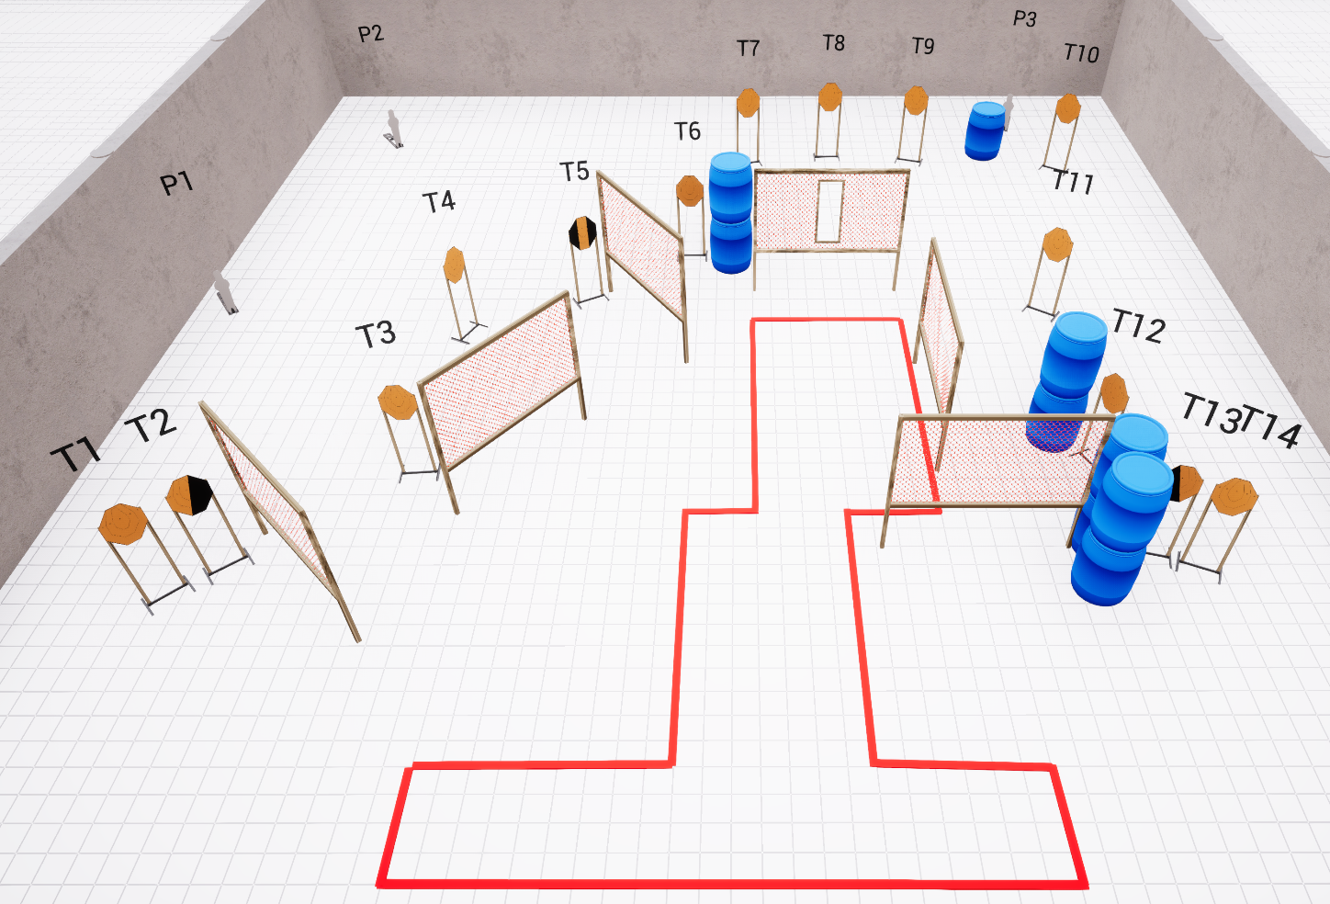

SETUP NOTES: 5 walls, 1 port wall, 3 mini-poppers; 4 double barrels, 1 single barrel |  | RO NOTES:

